Scope of this document | Describe Triage & Summary Sheet Changes
Date of document | 12/17/2010
Audience for this document | Medical Assistant and RN Users
Author | CodoniX Support

This document is intended as a brief description of new or changed functionality.
This document may be suitable for End User Reference

REASON FOR THE CHANGES AND EXPECTED BEHAVIOR:
A requirement of the EHR Incentive Program requires patient specific information must be documented. This change addresses Stage 1, Menu Set Objectives which all facilities must select 5 of the 10 requirements to qualify. Enforcements for each of the items can be turned on for your site. The specific information includes:
- Medications 80% of patients
- Allergies 80% of patients
- PMD/PCP 50% of patients
- Smoking 50% of patients 13 years or older
- Vitals which includes Height and Weight for BMI 50% of patients

Additional information that is recommended includes:
- Past Medical History
- Surgical History
- Family History
- Social History (marital status and employment)

To meet these requirements, the Triage screen has been modified. The CodoniX default Triage screen has been modified to support these changes and to streamline the workflow.

ADDITIONAL NOTES
If, your facility has a customized Triage screen, these new changes will not be visible. In order to use this new Triage screen, you need to send an email to jcm@codonix.com to have the triage screen switched to the CodoniX default. If, your facility is not currently enforcing the recommended items, notify jcm@codonix.com to have the additional items added to your site configuration.

If you wish to use the CodoniX default, but also wish to have customization done to the screen, the changes will be billable. Please contact ejd@codonix.com to receive a customization quote for changes to the default CodoniX Triage screen.

WORKFLOW ELEMENTS:
Triage Screen
- All items that are required for a facility are shown in red on the Triage screen.
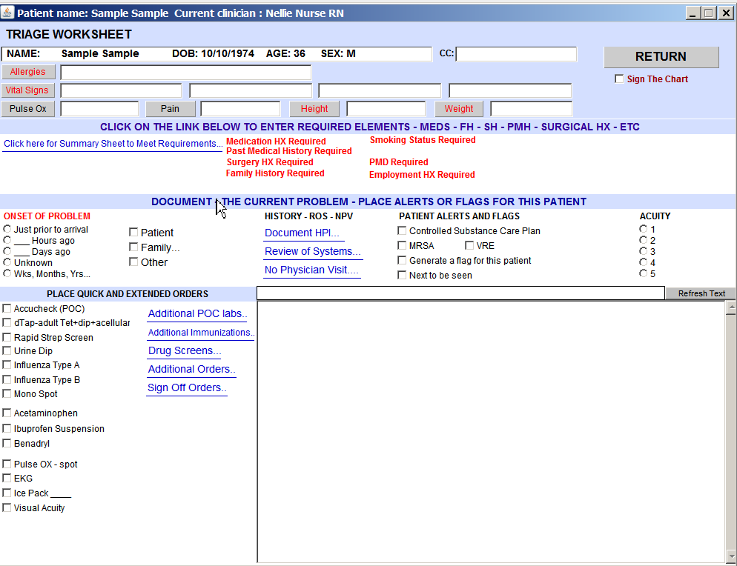
- The top portion of the Triage screen addresses requirements for patient Vitals. This section has not been changed.
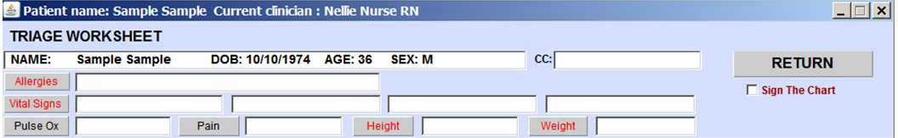
- The second portion of the Triage screen addresses the required elements which are specific EHR requirements. All items in this section are addressed on the Patient Summary Sheet. Information regarding changes to the Patient Summary Sheet can be found later in this document.

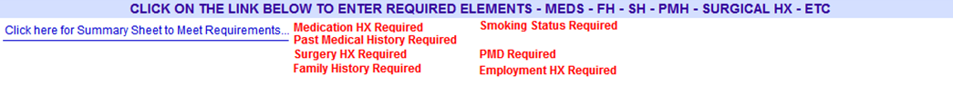
Clicking on the active link will take user to the Patient Summary Sheet to complete the necessary requirements.

All required elements are shown in red. As the items are completed, the text showing the requirement will disappear.

- The third portion of the Triage screen addresses the Patient’s Current Problem and any alerts needed for this patient. This section allows the user to document History, Review of Systems or No Physician Visit.
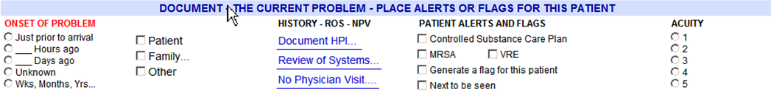
- The fourth portion of the Triage Screen provides access to common quick orders, all POC tests, Immunizations, Drugs screen, Additional Orders and Order Sign Off. This has been provided to streamline access to common Triage activities.

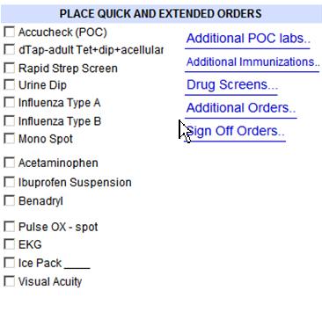
Summary Sheet
- Clicking on the active link on the Triage screen, will present the Patient Summary Sheet.

Required elements are shown on this screen also.
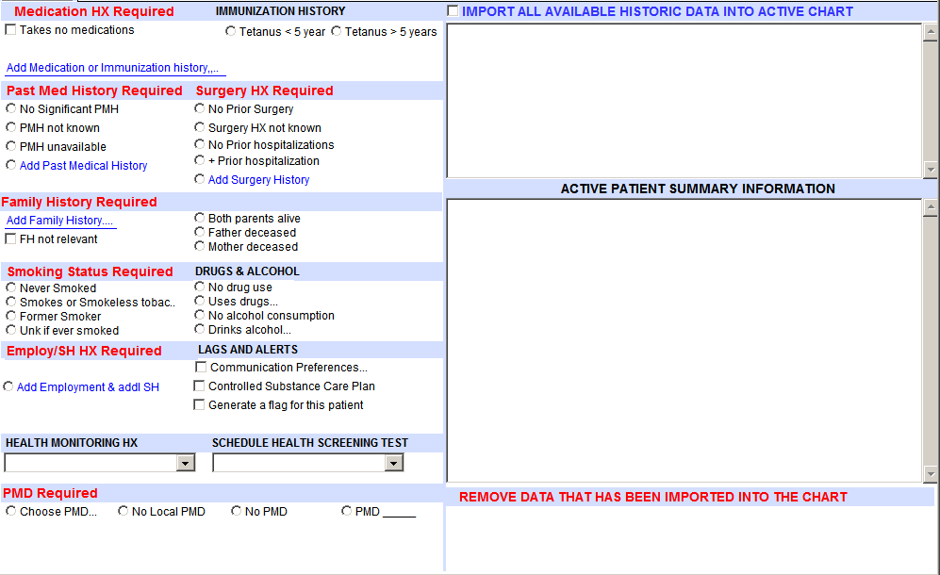

- Medication History. Entering Medication and Immunization History has changed. The steps for entering medication history for an Existing and New patient are described below.
  - EXISTING PATIENT: For a patient with existing medication history, which is imported from their previous visit, you first review and confirm their active medications which are shown in the Active Patient Summary Information section.
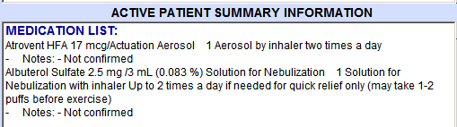
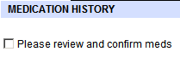

  - After you have reviewed and confirmed their historic information, you may click add medications and immunization information to review their entire medication history.
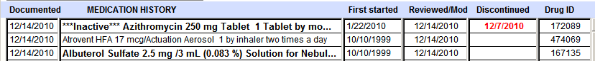
  - This new screen reflects all active and inactive mediations.
  - If you need to add a new medication, select Add a New Medication.
  - Select medication from the list 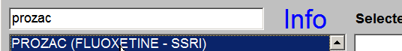
  - Click to select the dose information from the list
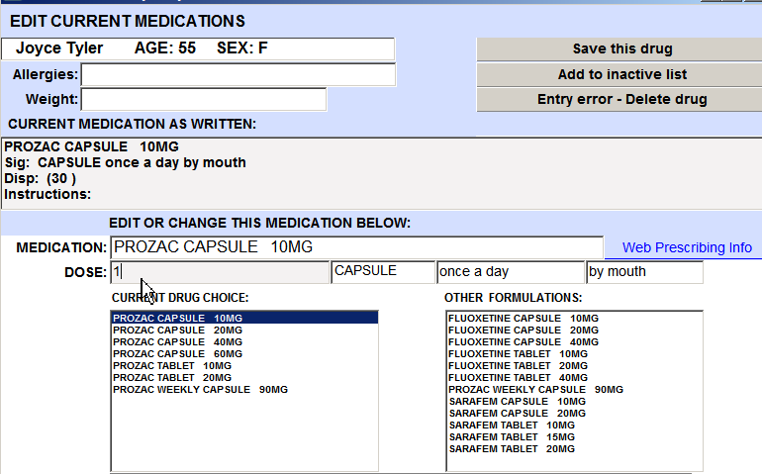
  - Enter a quantity then Save this drug
  - FOR A NEW PATIENT: You will begin on the medication list worksheet then complete steps d to f from above.
  - Note: The changes to medication list to reflect active and inactive medications is an EHR requirement.
- Immunization History. It is NOT a requirement to maintain a patient’s previous immunization history. You can, however, enter this information if you wish to keep an immunization history for a patient.
  - Select an immunization from the drop down list
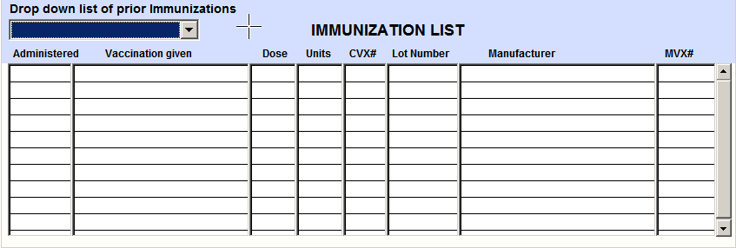
  - Complete information on the follow-up screen
  - 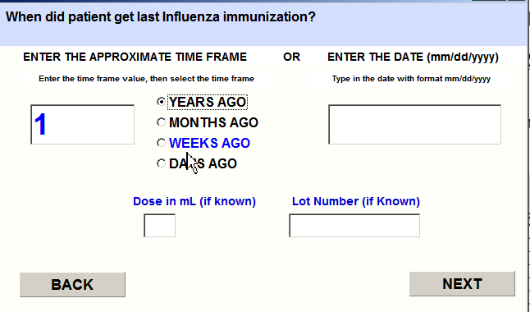
  - Select the brand
  - The immunization history is shown on the Immunization List. 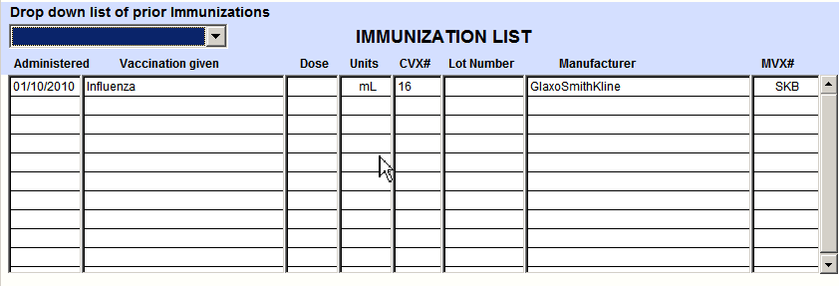
  - For immunizations given at your facility, this list is automatically updated.
- Past Medical History and Surgery History. These items are NOT required for EHR, but are recommended.
  - No changes have been made to entering Past Medical History. The revised Patient Summary Sheet does not support PMH not known and PMH unavailable.
  - 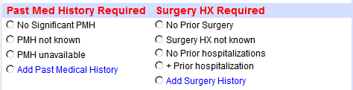
  - Surgery History now supports Surgery HX not known and No Prior hospitalizations.
- Family History. Family History documentation has not changed. The ability to document both parents alive, Father deceased, or Mother deceased has been added to this screen. 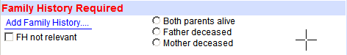

- Smoking History is an EHR Incentive requirement. The text for smoking history has changed to reflect the mandatory codes for smoking status. Each smoking status has a mandated code, for example Patient never smoked now show These codes CANNOT be removed from the text return in the chart.

- Communication Preferences. A patient’s communication preferences are an EHR Incentive requirement. This information is typically entered at time of registration. It is also accessible via the Patient Summary Sheet under the Flags and Alerts Heading. 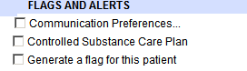
- Health Monitoring and Health Screen Tests. If your facility is maintaining a patients health monitoring and Health screen tests, this information can be entered from the patient summary. This information is NOT a requirement.
  - Health monitoring HX: This option allows the user to indicate relevant health monitoring. Selecting an item from the pull down list, allows the user to enter information regarding a previous health screen test.
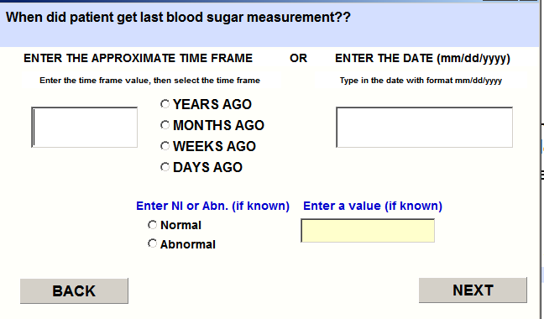
Schedule Health Screening Test: This option allows the user to indicate when a screen test needs to be done in the future. Selecting this option will generate a future task a request reminder to the Front Desk to contact the patient. Selecting an option from the pull down list allows the user to select when the next screening should be done. 