Scope of this document | Describe changes to Routine Orders Core Objective #1
Date of document | 12/17/2010
Audience for this document | All Users
Author | CodoniX Support

This document is intended as a brief description of new or changed functionality.
This document may be suitable for End User Reference

REASON FOR THE CHANGES AND EXPECTED BEHAVIOR:
A requirement of the EHR Incentive Program requires drug-drug and drug allergy checking to enabled for all medication orders. This change addresses Stage 1, 15 Core Set Objectives which all facilities must meet to qualify. This functionality must be available for ALL medication orders. This functionality is turned on as part of the E-Prescribing package. Changes to the Routine Order screen have been made to support this functionality.

In addition to supporting the requirement for drug-drug and drug allergy checking on the routine order screen, the CodoniX default routine order screen has been changed to support a separation of Send Out Labs and Send Out X-Rays.

ADDITIONAL SETUP NOTES
If, your facility has a customized Routine Orders screen, these new changes will not be visible. In order to use this new Routine Order screen, you need to send an email to jcm@codonix.com to have the Routine Order screen switched to the CodoniX default.

If you wish to use the CodoniX default, but also wish to have customization done to the screen, the changes may be billable. Please contact ejd@codonix.com to determine if your site is eligible for customization to the Routine Order screen.

WORKFLOW ELEMENTS:
A general overview of the changes which have been made to the Routine Orders screen can be found on the following pages.

Routine Orders revised screen
The revised Routine Orders screen has been changed to support selection of:
- In House or Send Out
  - Common lab orders are shown on the main screen, access to all labs is available by clicking the active link.
- In House or Send Out X-Rays
  - Common X-Ray orders are shown on the main screen, access to all X-Rays is available by clicking the active link.
- Medications Groupings provide common medication orders grouped together for faster access.

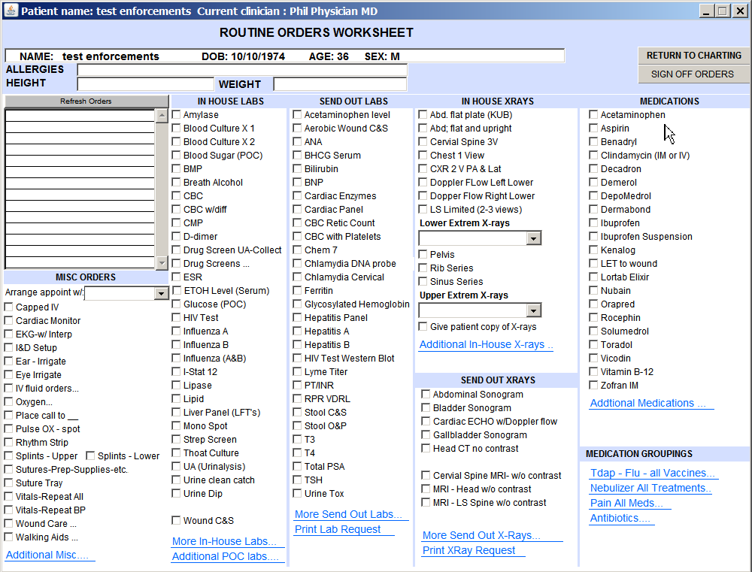
1
2
3

