Scope of this document | Describe new registration requirements Core Objective #4
Date of document | 10/30/2010 9:19 AM
Audience for this document | Registration Users
Author | CodoniX Support

This document is intended as a brief description of new or changed functionality.
This document may be suitable for End User Reference

REASON FOR THE CHANGES AND EXPECTED BEHAVIOR:
A requirement of the EHR Incentive Program requires key patient demographic information be entered for patients. This change addresses Stage 1, 15 Core Set Objectives which all facilities must meet to qualify. While the requirement states that 50% of all patients should have these key elements, at this time, CodoniX recommends 100% compliance. The CodoniX default registration screen has been modified to include enforcing all necessary fields. The required fields on the registration screen are as follows:
- Gender
- Date of Birth
- Last Name
- Race NEW field
- Ethnicity NEW field
- Preferred Language NEW field
- Financial Class
- Phone (at minimum 1 phone number, either home, work or cell)

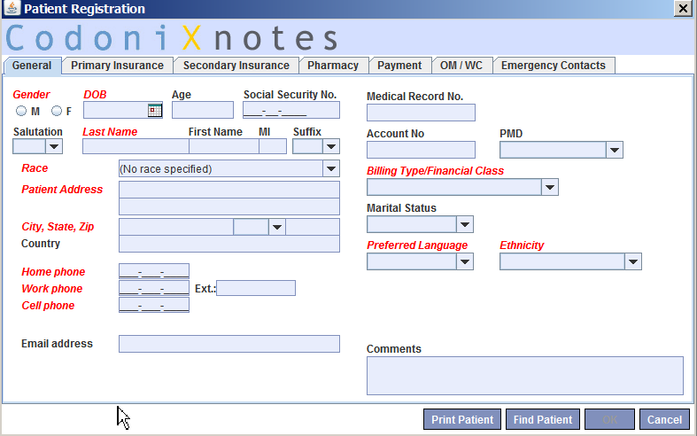

NOTE: If you are not currently using the CodoniX Registration Screen, contact the vendor you are using to register patients and confirm they meet this requirement.

WORKFLOW ELEMENTS:

Three new fields have been added to the registration screen. Each pull down list associated with the new field meets the classification standards required. No changes or additions can be made to these pull down lists. Each new field is described below.

Race
The race categories defined in the pull down list is based on the HIT requirements. You must select the race that is closest to the patient’s race. No additional race categories will be added to this list.
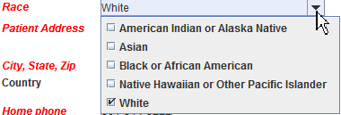

Preferred Language
Select from the pull down list.
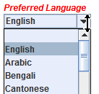

Ethnicity
The Ethnicity options are also defined by HIT requirements. There will be no additional Ethnicity added.
