Scope of this document | Introduce new functionality for Problem List Core Objective #5
Date of document | 12/17/2010
Audience for this document | CodoniX Support
Author | Andrew Muchmore

This document is intended as a brief description of new or changed functionality.
This document may be suitable for End User Reference

REASON FOR THE CHANGES AND EXPECTED BEHAVIOR:
A requirement of the EHR Incentive Program requires an active problem list is maintained for 80% of patients. This change addresses Stage 1, 15 Core Set Objectives which all facilities must meet to qualify. While the requirement states that 80% of all patients should have these key elements, at this time, CodoniX recommends 100% compliance by enforcing documentation of this element.

WORKFLOW ELEMENTS:
Access to the Problem List is available from
- The Provider Main Note 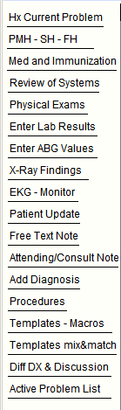
- The Summary Sheet 
- Or by clicking on any active problem within the chart

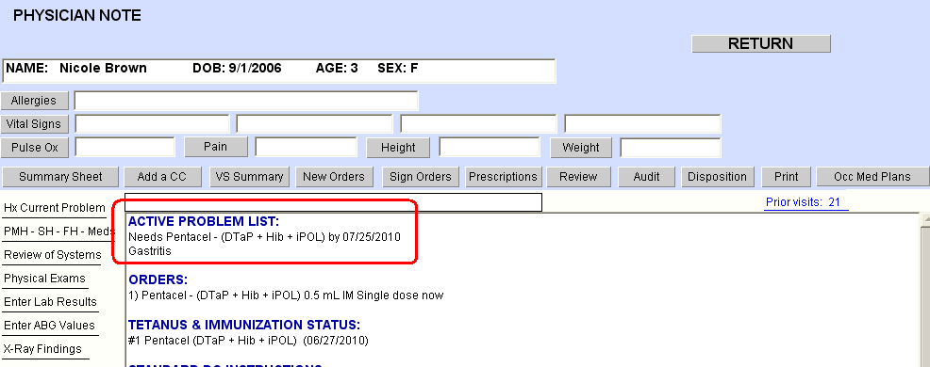

This brings up the new screen shown below

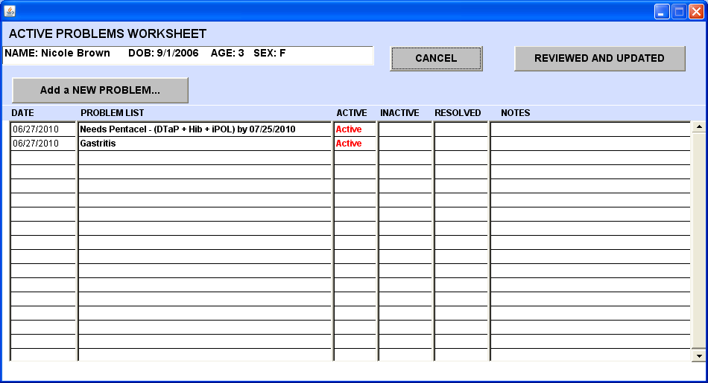

This screen documents the date of when the problem started and whether it is Active, Inactive, or Resolved. It also supports notes about each of the problems. To add a new problem click on the upper left hand button “Add a NEW PROBLEM”

This brings up the standard scrolling list – in this case we are going to choose Intussception

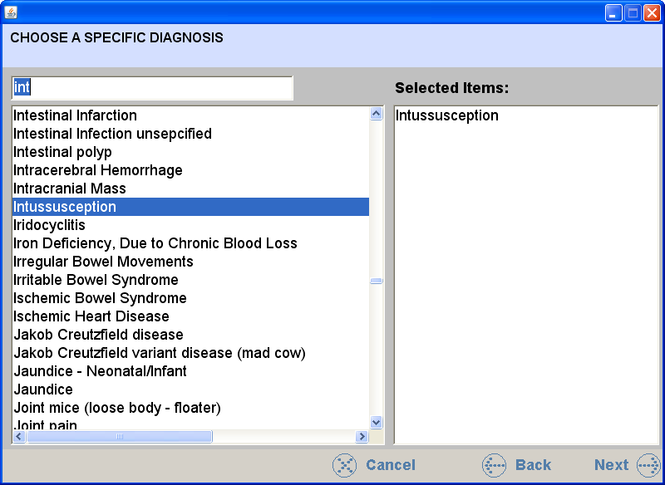

Note in the screen below that there are now 3 Active problems.

Lets make one of them Inactive – in this case we made Gastritis inactive and entered a note as to why it is now inactive

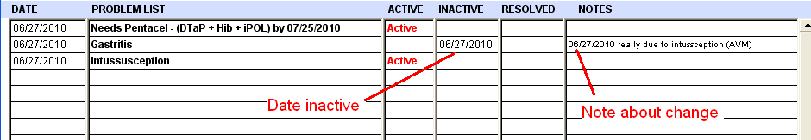

Returning to the Physician Note now shows only 2 Active problems (Needs Pentacel… and Inussusception)

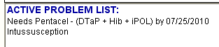

We can add or modify the Active Problem list at any time by simply clicking on one of the entries. If there are NO active problems – they can always be added using the existing work flow in the summary sheet which allows adding new problems. In addition we have added a new link to the Physician Note Graphic which allows updating the Active Problem list from that screen as well – see below

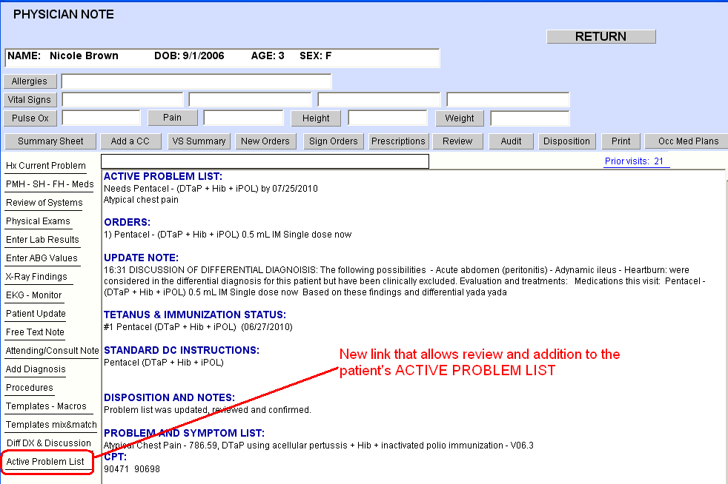

Now lets enter that the Intussception has been definitively treated and is now “Resolved”

