Scope of this document | Describe new reports – Patient Lists Menu Set Objective #4
Date of document | 12/17/2010
Audience for this document | Managers
Author | CodoniX Support

This document is intended as a brief description of new or changed functionality.
This document may be suitable for End User Reference

REASON FOR THE CHANGES AND EXPECTED BEHAVIOR:
A requirement of the EHR Incentive Program requires 20% of all unique patient 65 years or older or 5 years old or younger were sent an appropriate reminder. This item is part of the Stage 1 Menu Set objectives, all facilities must select 5 items from the list of 10 options to qualify. This requirement is met using an existing management report, Patient Reminder - . Additionally, 3 new reports are available via Management reports to generate reminder lists for patients. These reports include patient’s communication preferences.

The reminder lists are:
- Patient’s lab based on selection of
  - **Hi (high)
  - *P* (Panic)
  - Abn
  - H
  - Hi
  - Low
  - N
  - Nl
- Patient’s taking a selected medication
- Patient’s with a selected Problem

NOTE: These reports are Patient Centric and CANNOT be run individually for sub-sites. If your facility has subsite, the report will reflect all patients for all sites. The location where the patient was seen is displayed in the Patient Communication portion of the report.

Samples of these reports can be found on the following pages.

SAMPLE REPORTS

Lab Reminder Report
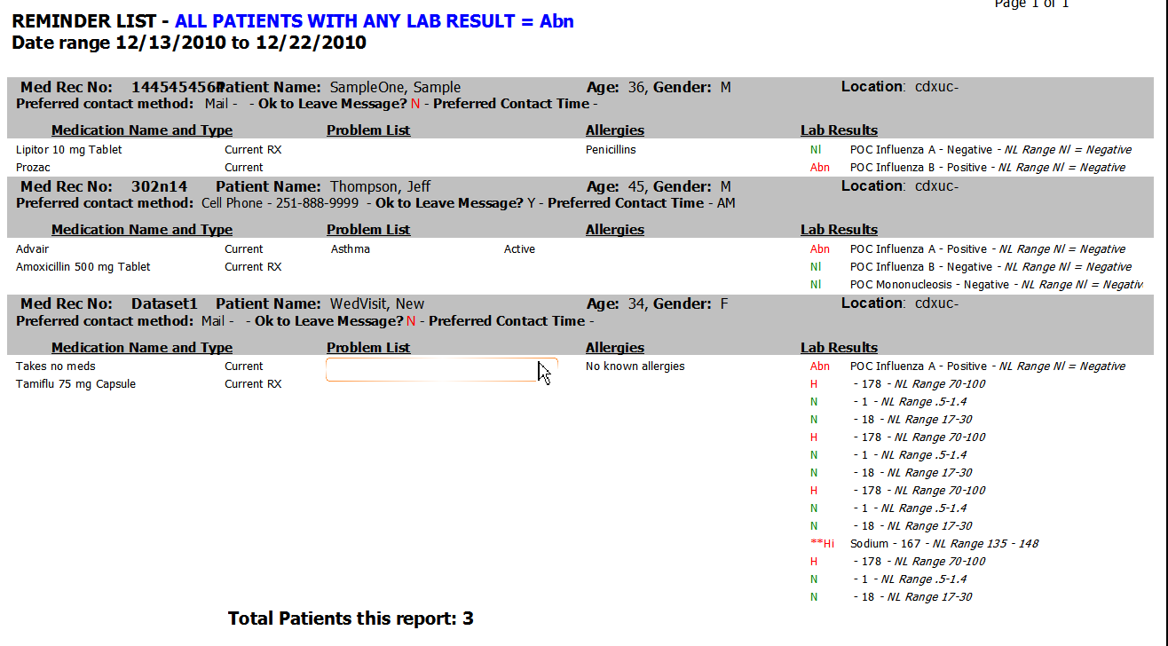

Problem List Reminder Report
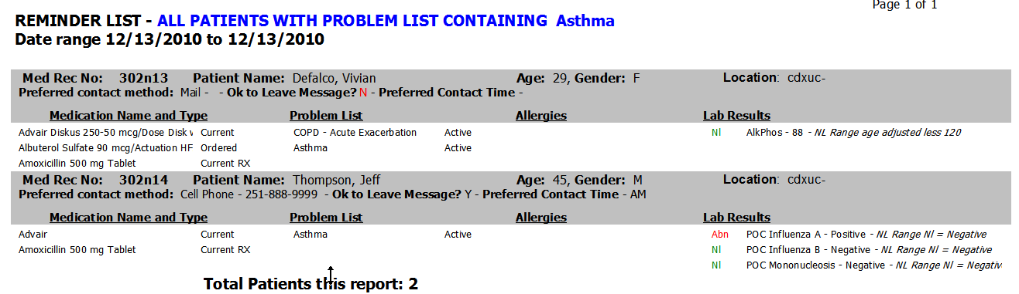

Medication List Reminder Report
