Scope of this document | Describe Patient Communication changes
Date of document | 10/30/2010 9:28:00 AM
Audience for this document | All
Author | CodoniX Support

This document is intended as a brief description of new or changed functionality.
This document may be suitable for End User Reference

REASON FOR THE CHANGES AND EXPECTED BEHAVIOR:
A requirement of the EHR Incentive Program requires patient communication preferences be documented. This change addresses Stage 1, Menu Set Objectives which all facilities must select 5 of the 10 requirements to qualify. This item can be turned on for your site if you select this as one of the 5 requirements you plan to meet.

The information collected includes:
- Preferred method for patient communications
- If a message can be left on voice mail
- Preferred time to call

WORKFLOW ELEMENTS:
If this option has been turned on as a requirement for your facility, the Patient Communication Preferences screen will be display as part of the start a patient workflow. (The required screen will automatically appear.)

- On the Patient Communication Preferences screen, select the Method to contact
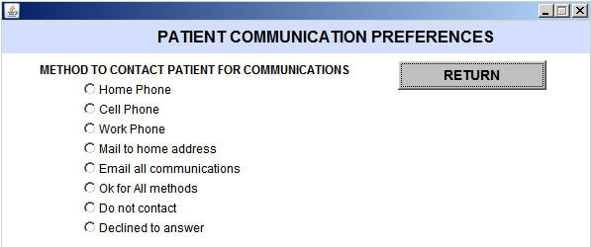
- Based on the Method to Contact selection, additional selections for Leave a message preferences and preferred time to call will appear.
- 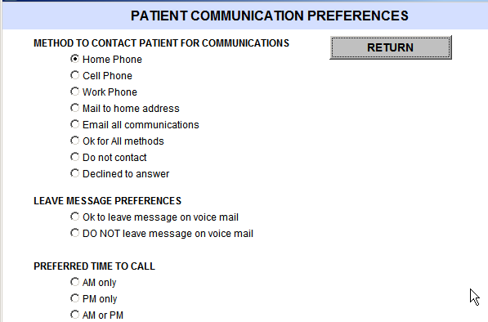

A patient’s communications preferences are visible, when hovering over the patient’s name for the following screens:

- Patient Follow-Up Call screen
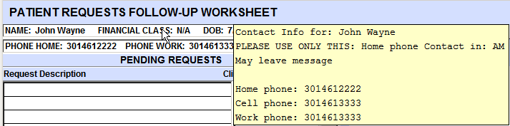
- Clinician Task and Request worksheet
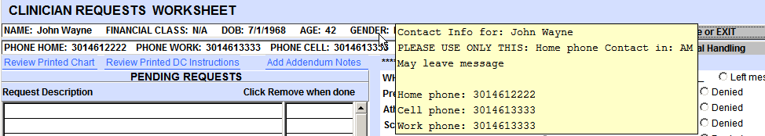
- Front Desk Task and Request worksheet
- Review Previous Visit, Chart Review Screen
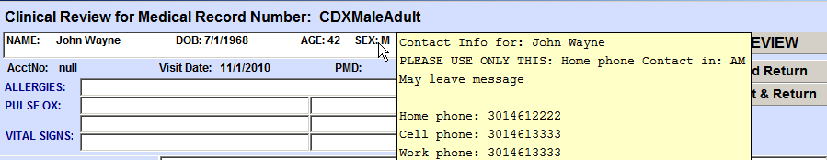
- Addendum Notes screen

A patient’s communication preferences are visible when hovering over the Pt Contact Info! On the Addendum Notes screen.
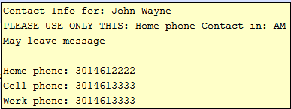

If this information is optional for your facility, patient communication preferences can be documented from the Front Desk screen or from the general follow-up screen.

From Front Desk screen
- Under Misc Items, select Communication Preferences
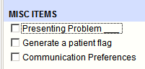

From General Follow-up screen
- On the disposition screen, under Follow-up Arrangement, select Referral Appts-Follow up-Departure Tasks
- 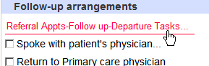
- Under Special Considerations, select Review/Change Patient Communication Preferences
- 