Scope of this document | Describe options to document Patient requests and Provider requests for Health Information Core Objective #12, #13
Date of document | 12/17/2010
Audience for this document | All Users
Author | CodoniX Support

This document is intended as a brief description of new or changed functionality.
This document may be suitable for End User Reference

REASON FOR THE CHANGES AND EXPECTED BEHAVIOR:
A requirement of the EHR Incentive Program requires providing patients with an electronic copy of their health information upon request. Additionally clinical summaries are provided to at least 50% of all patients within 3 business days. This addresses Stage 1, 15 Core Set Objectives which all facilities must meet to qualify.

The Patient Portal allows patient instant access to an electronic copy of their health information. Patients should be informed of this option. Documenting that the patient was informed of the Patient Portal is available in the following locations:
- On the MA/RN disposition screen
- Via addendum notes

Documentation of Patient informed about Patient Portal can be enforced at disposition for the MA/RN. To add this enforcement, contact jcm@codonix.com.

WORKFLOW ELEMENTS:
- Documenting a patient request for information and informing the patient about Patient Portal are available on the MA/RN disposition screen.
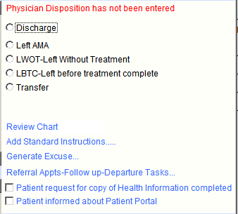
- Documenting a patient or PMD request for health information post visit is done from the Addendum Note screen.
