Scope of this document | Describe changes to MA/RN Disposition Core Objective #12, #13
Date of document | 12/17/2010
Audience for this document | MA/RN Users
Author | CodoniX Support

This document is intended as a brief description of new or changed functionality.
This document may be suitable for End User Reference

CHANGES TO WORKFLOW ELEMENTS:
A requirement of the EHR Incentive Program requires providing patients with an electronic copy of their health information upon request. Additionally clinical summaries are provided to at least 50% of all patients within 3 business days. This addresses Stage 1, 15 Core Set Objectives which all facilities must meet to qualify.

The Patient Portal allows patient instant access to an electronic copy of the health information. Patients should be informed of this option before their departure. Documenting that the patient was informed of the Patient Portal is available on the MA/RN disposition screen. Additionally, the ability to document a patient’s request for health information has been completed can be documented on the MA/RN disposition screen.

Documentation of Patient informed about Patient Portal can be enforced at disposition for the MA/RN. To add this enforcement, contact jcm@codonix.com.

This screen has also been modified to streamline disposition.

Information regarding the changes to the disposition screen can be found on the following page.

Provider’s disposition decision, the ability to Review Chart,
Add Instructions
Generate Excuse,
Add referral appointments and departure tasks are available in this box.
The 2 key requirements for patient requests and Patient Portal are available here

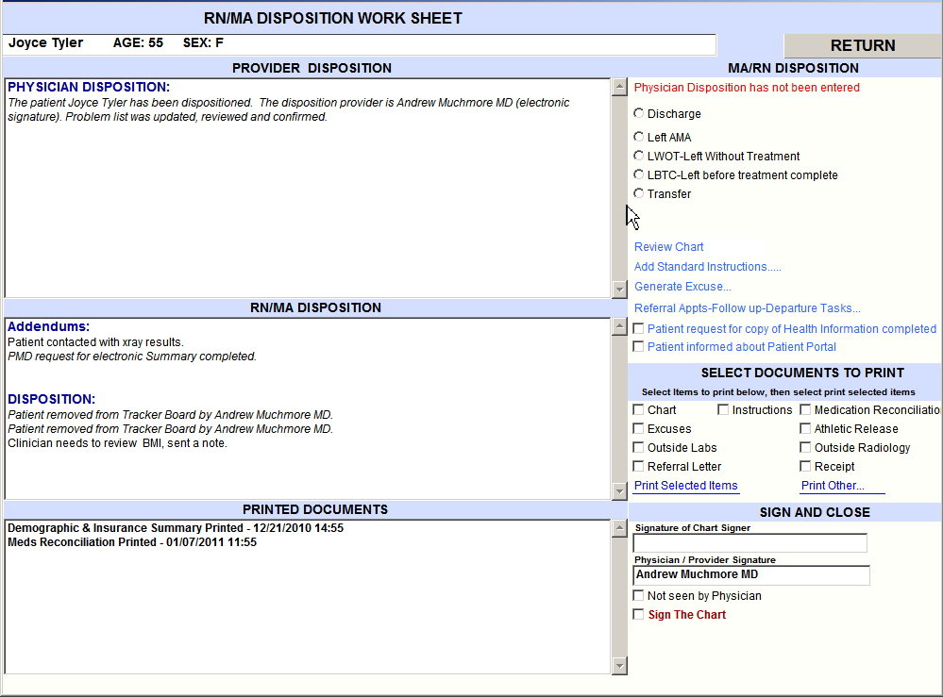
Information entered by the Provider appears in this box
Instructions selected and MA/RN disposition documentation appear in this box
Documents that have been printed appear in this box
Selecting documents to print is available in this box
Signature of the RN/MA and the provider are visible in this box

