Scope of this document | Describe E-Prescribing Core Objective #3
Date of document | 12/01/2010
Audience for this document | Providers
Author | CodoniX Support

This document is intended as a brief description of new or changed functionality.
This document may be suitable for End User Reference

REASON FOR THE CHANGES AND EXPECTED BEHAVIOR:
A requirement of the EHR Incentive Program requires E-Prescribing be available. This change addresses Stage 1, 15 Core Set Objectives which all facilities must meet to qualify. The requirement states that 40% of all permissible prescription written are transmitted electronically

SETUP REQUIREMENTS:
- Annual Fee of $650 paid.
- Provider registration with RxNT completed.
- Copy of Provider signature provided to CodoniX.

WORKFLOW ELEMENTS:

For E-Prescribing, to work, proper patient registration is critical.

Registration Requirements
- Patient information required
  - Name
  - DOB
  - Address
  - City, State and Zip
- Patient Preferred Pharmacy entered optional
  - Information can be entered at time of registration or
  - Provider must select a preferred Pharmacy at time of writing RX.
Provider Requirements
- Provider must be registered with RxNT
- Provider signature must be on file.

Additional Notes
- Available drugs and formulations are provided by First Data Bank.
- Additions to available drugs must be approved by First Data Bank.

Writing a Prescription for electronic submission
- As a provider, select Prescriptions from the Main Physician Note 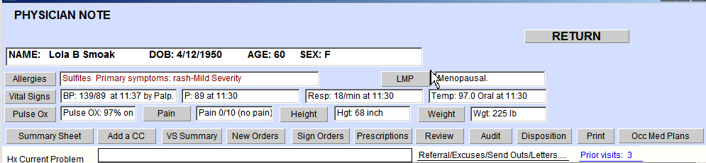

- On Prescription Worksheet, choose Select drug from list
- 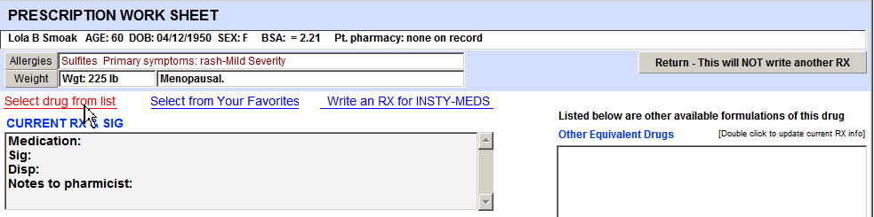
- On scrolling list, select drug 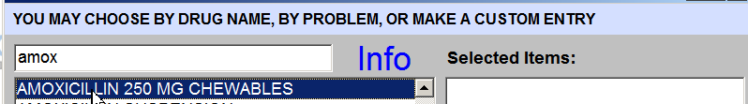
- On the Prescription worksheet
  - 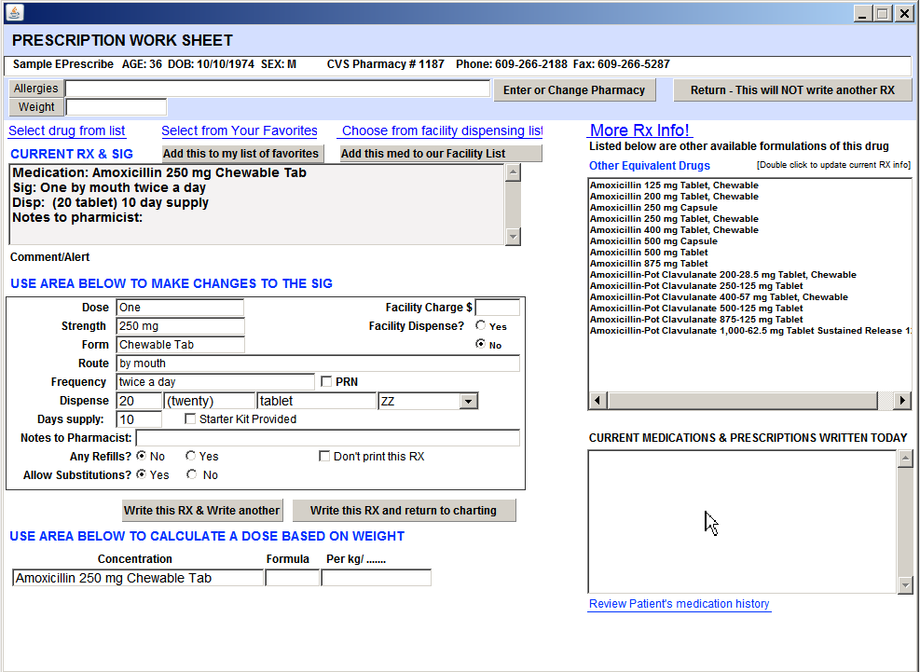
Current RX & Sign appears in box
Changes are made in the Change Sig box
Weight based calculations are done in the calculation box
Other available equivalent drugs appear in this box
Patient’s Current Medications appear in this box
To review patients complete medication history, select this active link

- When all information has been selected, click on Write this RX & Write another or Write this RX and return to charting.
- The E-Prescribe confirmation screen is presented

  - To accept the prescription and send, select Write this Prescription
  - To accept the prescription and NOT SEND, select Do Not Send this Prescription

  - 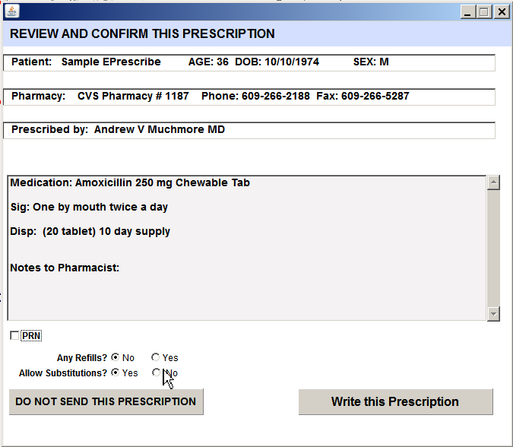

- If you elect to write and send, a confirmation will appear in the chart

Using Existing Favorite Lists
- Existing medications stored in your favorites list will work with E-Prescribing with the following exceptions.
  - Formulations not supported by First Data Bank will be rejected.
  - Favorites for medications removed from the market will be rejected.

Generating a refill from Current Medications
- When current medications are entered, complete information MUST be entered to convert a current medication to a RX.

Incorrect entry – Dose information not entered Correct entry – Dose information entered
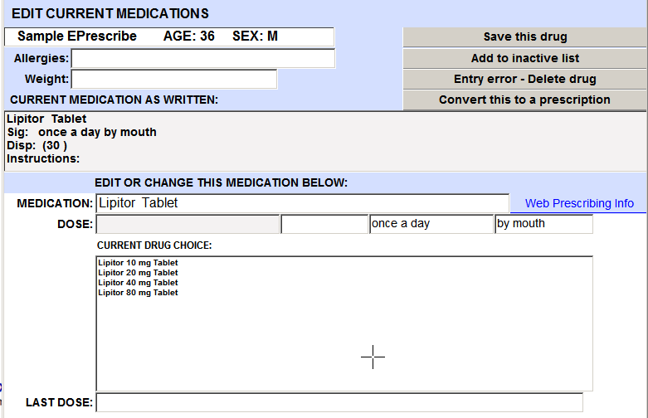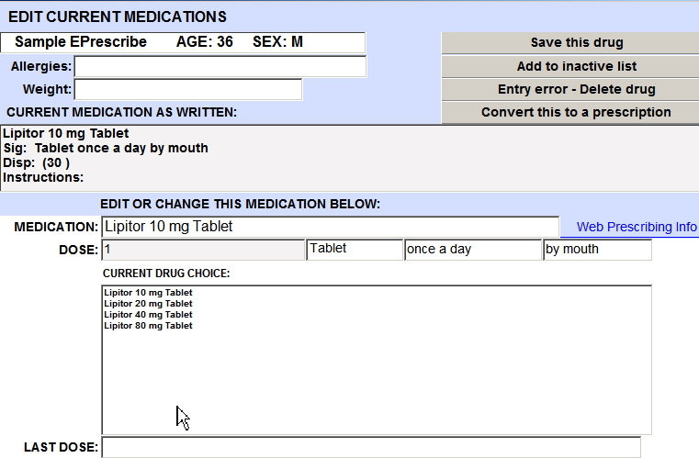

Reviewing Prescriptions submissions
- From the Trackerboard, select Tool -> Prescriptions 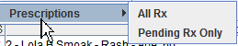
- To View all prescriptions sent electronically, select All RX
- Enter your user ID and a date range 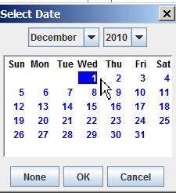
- A list of all prescriptions written for E-Prescribing and their status will be displayed.
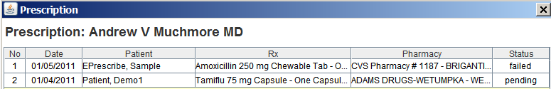
- Selecting Pending RX Only will display a list of all pending RX’s.

