Scope of this document | Describe Drug/Drug Interactions, Drug Allergy and Formulary Core Objective #2 and Menu Set Objective #1
Date of document | 12/17/2010
Audience for this document | Providers
Author | Andrew Muchmore

This document is intended as a brief description of new or changed functionality.
This document may be suitable for End User Reference

REASON FOR THE CHANGES AND EXPECTED BEHAVIOR:
- To meet the new HIT guidelines for Meaningful Use.

INTRODUCTION:
Our new e-prescribing brings a number of benefits including automatic screening for Drug/Drug and Drug/Allergy interactions. In addition the patient’s insurance drug coverage will automatically be queried and you will be notified if a drug is “On formulary” “Preferred” or “Off formulary”. In every case you have the ability to review and override any of this information and write the prescription if you think it is appropriate.

You will note that there is a new ‘lag time’ of up to 4-5 seconds when writing for drugs. This is because in the background we are checking the patient’s insurance literally against all policies in the country, we are matching the patient’s preferred pharmacy to a list of all pharmacies in the country, and we are looking up the particular drug that has been ordered and checking for other drugs and interactions against the First Data Bank Drug database that has more than 12,000 active drugs. We are working on speeding up these queries to be as fast as the non look up version.

Another thing that you might notice is that some drugs may not be available. This is controlled by the First Databank Database – this is updated at least every week and is a list of EVERY valid drug as of that day. There is one idiosyncrasy that we do not have control over. If a drug is ONLY available as a Brand Name – it will not show the generic name as an option. This should not be a problem since most people will write the brand if the generic form does not exist in the market.

WORKFLOW ELEMENTS:

DRUG/DRUG and DRUG/ALLERGY INTERACTIONS:

We have set up a patient who is allergic to “Penicillins” and is taking “Coumadin”

For drug/allergy interactions we will try to write a prescription for “Keflex” – i.e. cephalosporins may cross react with penicillins.

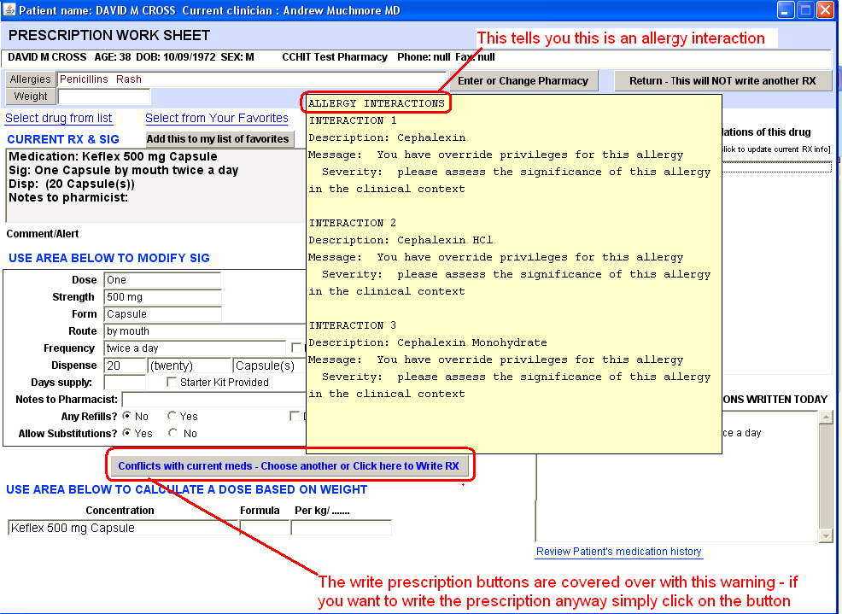

A similar screen will appear for Drug/Drug interactions. In this case we are going to write a prescription for Plavix in this patient who is already taking coumadin.

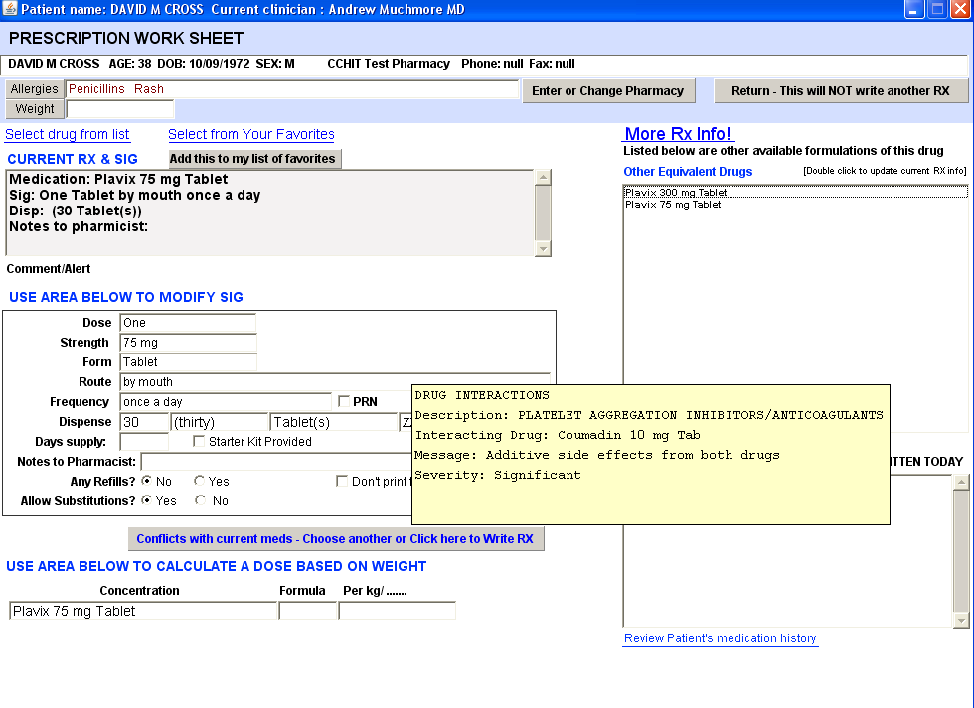
Note in this case this is listed as a “DRUG INTERACTION” and the Severity is listed as significant.

We have the ability to show all possible interactions or to suppress interactions to only display the very most serious interactions.

DRUG FORMULARY.

If a patient has drug coverage through their insurance you will be notified concerning the appropriate coverage. An example of a preferred drug is shown below

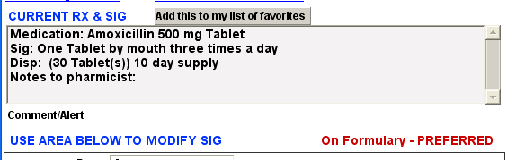

The next drug “Lipitor” is on Formulary but it is NOT ‘PREFERRED”

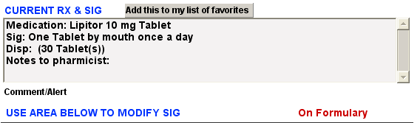

Finally a drug that is “Not Covered is shown below”

