Scope of this document | Describe Clinical Decision Support Rule for Community Acquired Pneumonia - Core Objective #10
Date of document | 12/17/2010
Audience for this document | Providers
Author | Dr. Muchmore

This document is intended as a brief description of new or changed functionality.
This document may be suitable for End User Reference

REASON FOR THE CHANGES AND EXPECTED BEHAVIOR:
A requirement of the EHR Incentive Program requires the ability to use 1 clinical decision support rule. This requirement addresses Stage 1, Core 15 Objectives which all facilities must meet to qualify. The requirement is part of the CodoniX default, no action is required to use this Clinical Decision Support Rule.

We have taken the treatment of Community Acquired Pneumonia (CAP) and incorporated rules from the CMS PQRI registry as well as recommendations from IDSA. The rules are summarized below.

There are 4 quality measures that already exist as PQRI reportable elements for the treatment of Community Acquired Pneumonia (CAP) the corresponding NQF identifiers are listed below.
- NQF 0242 – Patients with CAP should have a full set of vital signs
- NQF 0234 – Patients with CAP should have a Mental assessment
- NQF 0233 – Patients with CAP should have pulse oximetry recorded
- NQF 0096 – Patients with CAP should be treated with an appropriate antibiotic – either a macrolide, fluroquinolone, synthetic penicillin or a cephalosporin

In addition to these criteria the Infectious Disease Society of America (IDSA) and the American Thoracic Society (ATS) have released guidelines that strongly recommend obtaining a formal “CURB” score (Confusion, BUN, Respiratory rate, Systolic Pressure and Age) this score should be evaluated in the context of additional risk factors and the score determines the antibiotic regimen and whether this can be handled as an outpatient or inpatient.

We have incorporated all of these elements into the following work sheet shown below with no clinical information entered. Note that there are a number of prompts in red and requirements shown as “Need”.

The following pages describe the workflow.

WORKFLOW ELEMENTS:

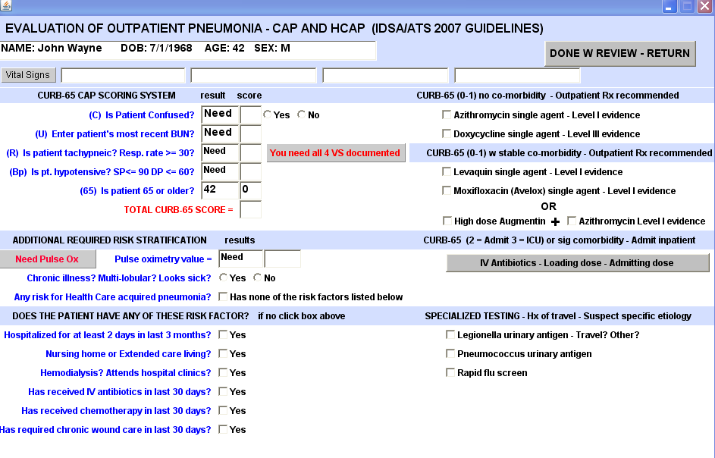

This work sheet is AUTOMATICALLY activated the minute the diagnosis of CAP is made. This is usually done at the time of the interpretation of a chest x-ray.

Steps to meet the criteria.

- We need an empty pre-staged patient to enter clinical data
- As a physician order a chest X-ray and interpret it
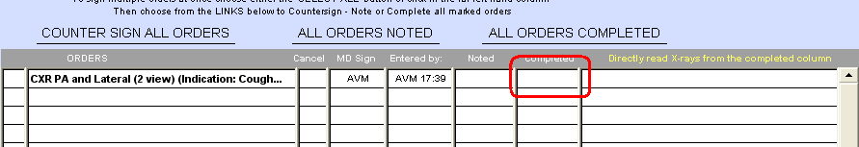
- Choose Pneumonia/Infiltrate

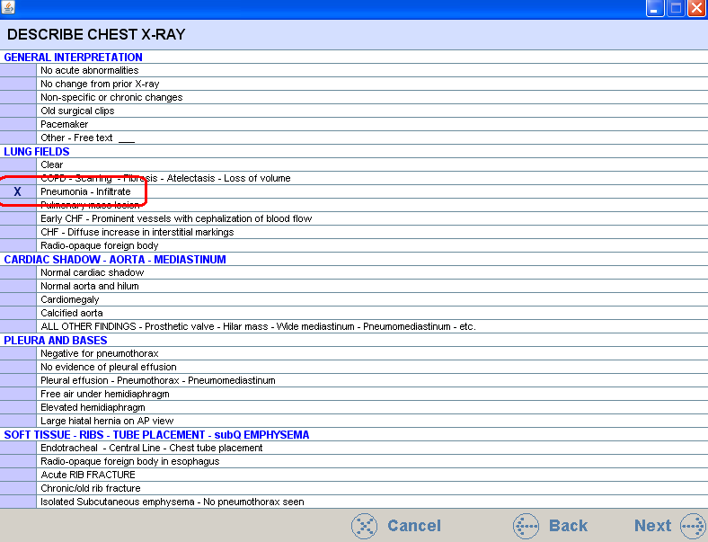
- Choose Community Acquired Pneumonia

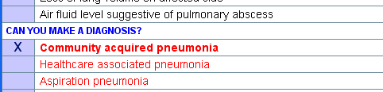
- Since this chart has ONLY an x-ray order (i.e. no clinical data has been entered you will get the following warnings

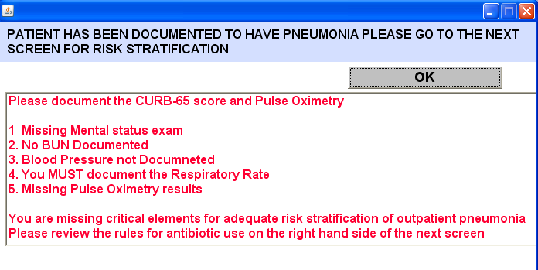

The Worksheet without any information entered is shown below

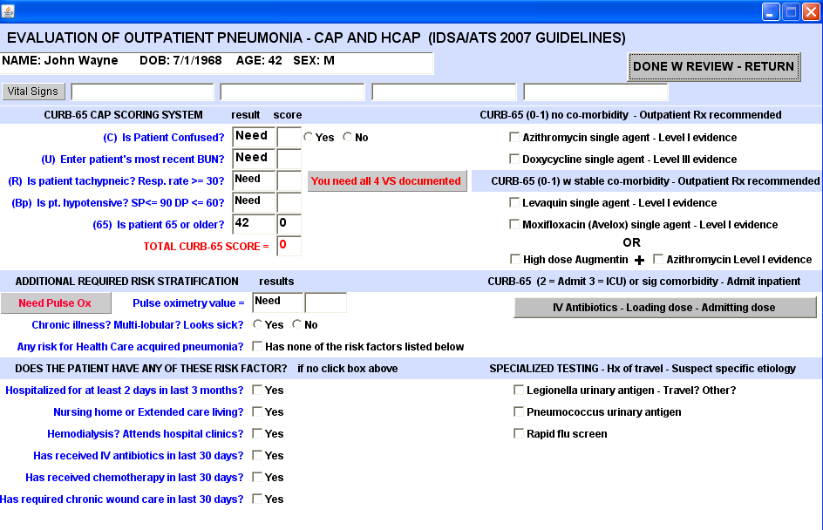

This is what the work sheet looks like when fully populated

