Scope of this document | Automatic Log Off
Date of document | 12/17/2010
Audience for this document | Administrators – Impacts all users
Author | CodoniX Support

This document is intended as a brief description of new or changed functionality.
This document may be suitable for End User Reference

REASON FOR THE CHANGES AND EXPECTED BEHAVIOR:
- To meet the new HIT guidelines automatic log off has been added as a feature, this is NOT a requirement for your facility.
- If you wish to use the automatic log off, contact CodoniX Support to have automatic log turned on.

WORKFLOW ELEMENTS:
- Based on the Automatic Log time you select, user will be notified that due to inactivity the system will be automatically logged out. 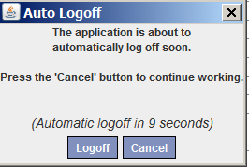
- The user may select cancel to cancel the log off. If cancel is not selected, the system will automatically log off. 